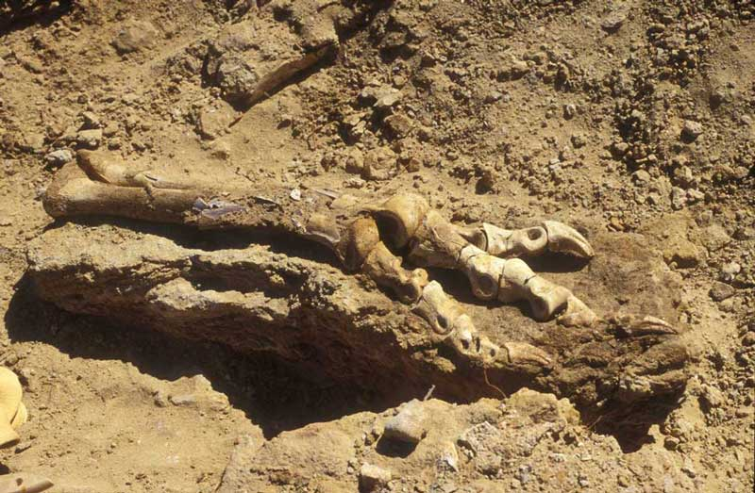
LOST DINOSAURS OF THE GOBI DESERT

SPECIAL PALEONTOLOGICAL JOURNEY

Trip Date: September 8 - 22, 2025

Scientific Goal and Significance of the 2026 expedition

Hunt for and collect dinosaurs alongside paleontologists at one of the richest fossil-rich localities in the Gobi Desert. The goal of this expedition is to discover and collect dinosaur remains and assist in international efforts to counter the black-market trade of illegal fossils from Mongolia.

Mongolia’s Gobi Desert is renowned as one of the richest areas in the world for the discovery of dinosaur fossils. Paleontological exploration there spans more than a century and has been the source of such emblematic dinosaurs as Velociraptor, Gallimimus, and Tarbosaurus. However, since the early 2000’s the illegal excavation and poaching of dinosaur fossils from across Mongolia have had a hugely damaging effect on its natural history heritage, with important specimens removed from public knowledge and the scientific community. During last year’s expedition to determine where in the Gobi these fossils were originally found, our team discovered an important skeleton of the tyrannosaur Tarbosaurus.

By participating in this expedition, you will help paleontologists excavate this exceptional new skeleton, access new areas of the Gobi, and hunt for new fossils along the way!

SCIENTIFIC LEADERS:

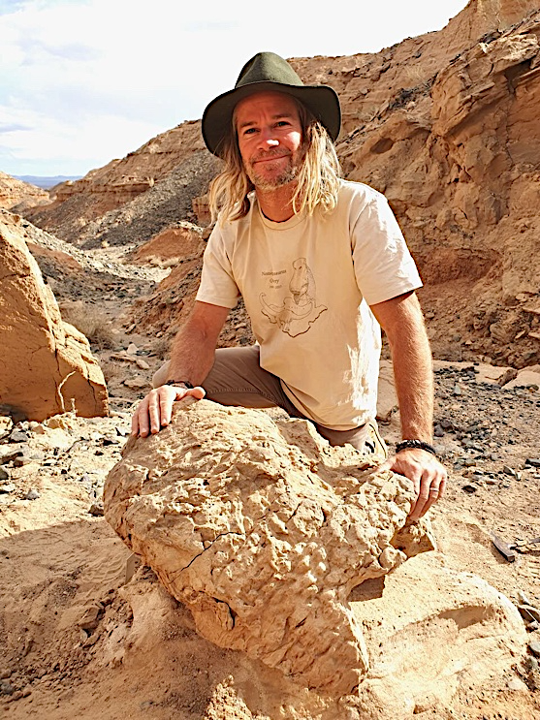

Dr. Phil Bell - With two decades of experience as a dinosaur expert, Australian paleontologist Phil Bell pioneered the application of geochemistry to determine the origins of illegally excavated fossils in Mongolia. He has lead expeditions in search of dinosaurs in Australia, Canada and Mongolia.

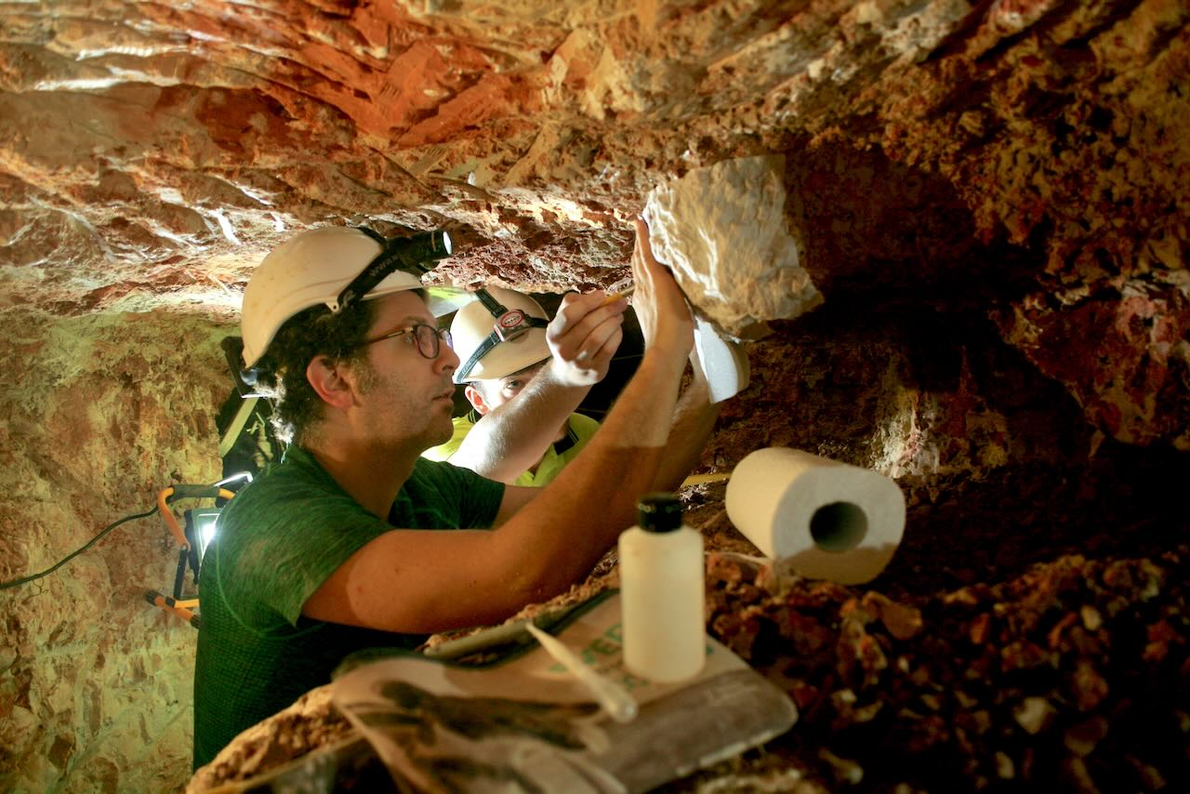
Dr. Nic Campione—Educated in the Canadian Badlands, Nic is a leading expert in the long-term evolution and extinction of dinosaurs. He is particularly interested in the body size evolution of dinosaurs and has led fieldwork in Canada, Australia, Uruguay, and now, Mongolia.

Detailed Itinerary

Day 1, Sep 8 Arrival
Upon arrival at the airport, meet your guide and transfer to a centrally located hotel located near downtown Ulaanbaatar.

Enjoy a welcome dinner at a fine local restaurant. Ulaanbaatar offers a contrast between ancient traditions and the dawning of a 21st century democracy, which can be seen in the traditional gers and Buddhist monasteries coexisting with modern high-rises. (Hotel Bayangol or similar; D)

Day 2, Sep 9 Gobi Desert / Gobi Gurvansaikhan Mountains
After breakfast, begin driving to the vast steppe to the Gobi Desert, comprised of mountains, sand dunes and fossil beds. In route, we will enjoy a picnic lunch along the way.

Continue driving until you arrive at a rustic ger-hostel, located near the Gobi Gurvansaikhan National park. Overnight in gers or tents. (Approx. 9 hours driving; Ger or tent stay; B, L, D)

Day 3, Sep 10 Gurvantes and Ingeni ​Khovur Basin
After breakfast, drive further south east to the deeper pocket of the Gobi desert. We will arrive at a remote basin in the Gurvantes soum, one of the most remote regions of the Gobi Desert. Arrive at your base camp and overnight in tents. (Approx. 6-7 hours driving; Tent camp; B, L, D)

Day 4-10, Sep 11-17 Bugiin Tsav and Ingeni ​Khovur Basin surveys
Our field work starts in full earnest today. We will start inspecting the skeleton of a Tarbosaurus discovered during the 2025 expedition. Each day, the team will be divided to achieve different tasks including, excavating the Tarbosaurus, hunting for new fossils and excavating the newly-discovered “Shuvuu bonebed”, an important fossil site rich in theropods, birds, and mammal fossils. Other objectives may include visiting historic excavations (quarries), locating poached quarries, collecting data for ant-poaching efforts, and excavating important new finds. Our base camp will most likely be at Guriliin Tsav locality, which is a secluded but one of the richest paleontological sites in the western Gobi Desert. ​Both Guriliin Tsav and Bügiin Tsav localities​ are located in the Ingeni ​Khovur Basin​ ​of Bayanhongor province ​a​nd is different from the nearby Nemegt successions ​ in reflect​ing tectonics and climate factors​. This area is considered to be important for understanding the uppermost Cretaceous stratigraphy and vertebrate faunal diversity in the Gobi ​Desert. The remoteness and vastness of these badland-like exposures​ make it an ideal location to focus on finding rare finds. Overnight in tents.
(Tent camp; B, L, D)

Day 11, Sep 18 Bugiin Tsav / Gobi Gurvansaikhan National Park
We will pack our gears this morning and drive back to the interim camp in the Gobi Gurvansaikhan National Park. Overnight in gers or tents. (Approx. 8 hours driving; Ger or tent camp; B, L, D)

Day 12, Sep 19 Tugrigiin Shiree / Flaming Cliffs
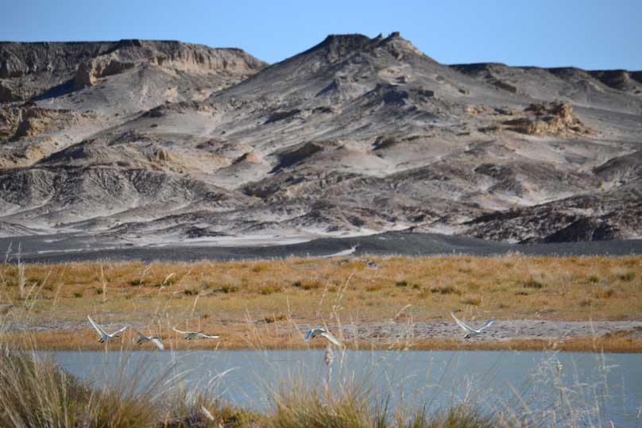
In the morning, we will begin driving to the Tugregiin Shiree, which was discovered by Mongolian scientists and co-explored by Polish expeditions in the late 1960s and
early 1970s. Tugrigiin Shiree is perhaps most known for its famous "Fighting Dinosaurs” (a fossil of a Protoceratops and a Velociraptor locked in combat), which were discovered in the 1970s. We will explore this white sandstone escarpment for dinosaur fossils.
Tugrug Lake – Photo by Mongolia Quest
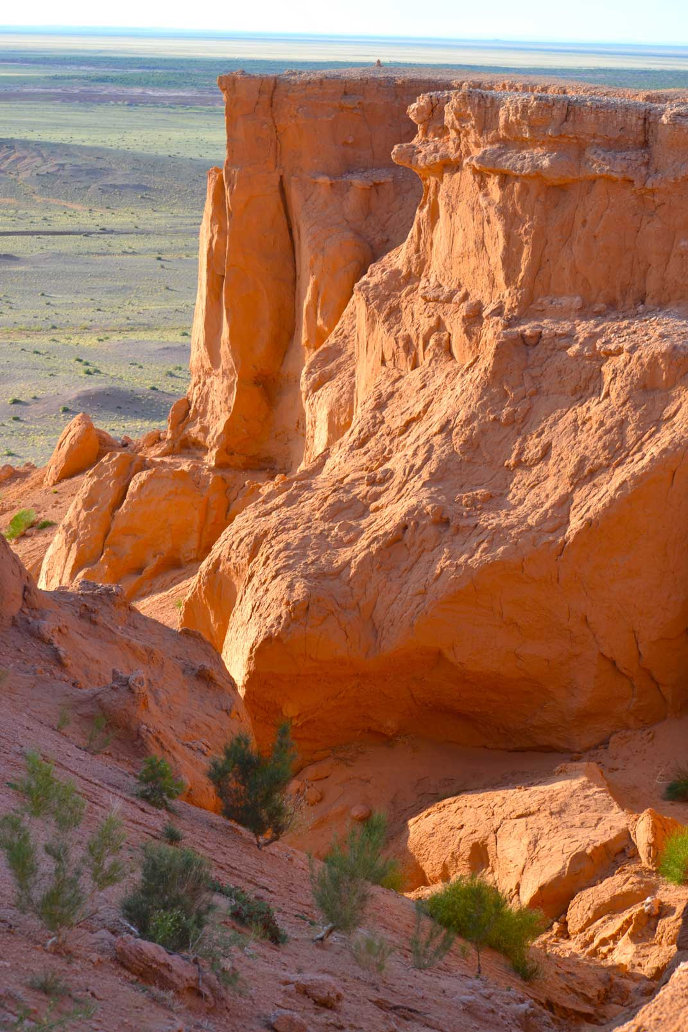
In the late afternoon, will drive to the legendary Flaming Cliffs, red sandstone formations that stretching over 3 kilometers in width, where hundreds of dinosaur fossils have been discovered over the course of the last century. Paleontological expeditions from many countries, including from the U.S, Poland, Japan and Russia have worked here during last 90 years. Each year, rain and wind reveal yet more fossils and every summer, exceptional new discoveries are made. We will explore the cliffs in the footsteps of legendary American explorer Roy Chapmen Andrews who discovered the first dinosaur eggs here, that the world had ever seen. Enjoy a sunset view at this majestic place before returning back to your ger camp. (Ger Camp; B, L, D)
Western edge of the Flaming Cliffs, Gobi Desert

Day 13, Sep 20 Gobi Desert / Ulaanbaatar
After breakfast, we will drive to Dalanzadagad for our return overland journey back to Ulaanbaatar. Upon arrival, transfer to our hotel and dinner is independent. (Approx. 9 hours driving; B, L)

Day 14, Sep 21 Ulaanbaatar
After breakfast, pay a visit to the Institute of Paleontology of Mongolia’s Academy of Science. Visi the laboratory and enjoy seeing some of the price exhibitions of the institution including the famous “fighting dinosaur:.

The remainder of the day is available for last minute sightseeing. In the evening, we will attend a performance featuring traditional Mongolian dancers and hoomi (throat) singers. (Hotel Bayangol or similar; B, L, D)

Day 15, Sep 22 Departure
After breakfast, we will transfer to the airport for departure. (B)

Mongolia Quest reserves the right to alter the above itinerary if deemed necessary
B=Breakfast, L=Lunch, D=Dinner

Land Prices:

Based on 4-5 participants: $6,250 per person, standard twin occupancy;
Based on 6-7 participants: $5,940 per person, twin occupancy;
Based on 8-9 participants: $5,820 per person, twin occupancy;
Based on 10 & more participants: $5,450 per person, twin occupancy;

Domestic flight (if available): $350 per person;

Optional single supplement: $650 per person (including a single tent at the field camp).

Land prices include:

- Land transportation as indicated in the itinerary based on using Toyota Land Cruiser jeeps seating 3 passengers each;
- Accommodations in a standard room at hotels, gers in the countryside based on a twin occupancy;
- Airport arrival and departure transfers;
- Sleeping bags; expedition style tents and mats;
- All meals indicated as B, L or D;
- All entrance fees as indicated in the itinerary;
- International trip leaders expenses and fees;
- Mongolian paleontologist to accompany the trip throughout;
- Mongolia Quest English speaking national tour manager;
- Bottled water per person per day and unlimited supply of boiled waters.

Land prices do not include:
International and domestic airfare; personal laundry and drinks not mentioned in the itinerary; travel insurance; medical evacuation costs; excess baggage charges; visa fees; gratuities; photography and video fees and any other item not mentioned as included.

How to book this trip
You may book any trip with us by filling out our Trip Application Form, which you can download using Adobe Acrobat Reader and can send to us as an electronic file via e-mail at Info@MongoliaQuest.com. All reservations are subject to deposit of $400 per person. Deposits are refundable until 90 days prior to the start of the program less a $250 administrative fee. Please arrange a wire transfer to Mongolia Quest bank account as per following instructions:

Beneficiary name: MONGOLIA QUEST LLC
Beneficiary's address:
Suite #504, Dalai Tower UNESCO Str 31, Sukhbaatar District - 1 Ulaanbaatar, Mongolia; Tel: (976) 7000 9747
info@MongoliaQuest.com

Beneficiary's account number: 3005111070
Beneficiary's bank name: Golomt bank
Beneficiary's bank address:
Monnis branch
3rd floor, Monnis tower, Chinggis avenue
Khoroo #1, Sukhbaatar district
Ulaanbaatar, Mongolia
Beneficiary's bank swift code: GLMTMNUB

Once we receive your trip application form, we will send you information about how to wire your deposit to us, and a confirmation letter with information related with visa and international airfare reservations. You will also receive our pre-departure Travel Guide, which will include information on weather, suggested reading list, a list of items to pack, etc.

About 4 weeks prior to your arrival date, we will send you Final Departure Information which will include your final itinerary along with any other necessary updated information regarding the logistics of your trip.

Payment and Cancellation Policy
As mentioned above, a deposit of $400 per person is required to reserve space for the trip that you have chosen. Full payment is due 90 days prior to the start of the trip. In the case of a cancellation, please contact us in written form.

Notification of cancellation must be received in writing by Mongolia Quest. At the time, we receive your written cancellation, the following penalties will apply:
· Up to 90 days prior to departure: $250 per person handling fee;
· 89-60 days prior to departure: 20% of the trip cost per person;
· 60-45 days prior to departure: 50% of the trip cost per person;
· 44-30 days prior to departure: 75% of the trip cost, per person;
· 29 days prior to departure, or after the trip starts: no-refund.

Some airfares may be nonrefundable. Once an expedition has departed, there will be no refunds from MQ for any unused portions of the trip. The above policy also applies to all extensions and independent travel arrangements made in conjunction with this program.

Tier pricing
Our prices are based on tier pricing. At the time of booking, we will bill you for the amount based on the confirmed number of trip participants. In case the number of travelers increases at the last moment, we will reimburse the balance of your payment in accordance with the corresponding tier pricing, after you return home.

Travel note
How to get to Mongolia
The official Mongolian international civil flight carrier is Mongolian Airlines or MIAT. Currently it serves flights between Beijing, Seoul, Tokyo, Hong Kong, Bangkok and Frankfurt. Other popular airlines include Asiana, Pusan and Turkish airlines. South Korea is the most common international gateway city to Ulaanbaatar. Mongolian Airlines and Turkish Airlines fly daily to/from Istanbul. If you are coming from Europe, you may also find Turkish Airlines a convenient connection. During the summer season, if no seats are available on any of these major carriers, there are ways to fly to Mongolia through local cities in China and Russia. Please contact us for more information. The seats are usually in high demand and booking needs to be done well in advance.

Visa Information
U.S, Canadian, Japanese, Australian and citizens of most European counties are allowed to enter Mongolia without a visa for up to 30 days. All other nationals are required to get a visa before entering Mongolia.

THE LIST OF THE COUNTRIES TO BE EXEMPTED FROM VISA REQUIREMENTS TO VISIT MONGOLIA UP TO 30 DAYS IN THE YEARS OF 2023-2025
- Republic of Austria
- Kingdom of Belgium
- Hungary
- Hellenic Republic
- Kingdom of Denmark
- Kingdom of Spain
- Italian Republic
- Republic of Latvia
- Republic of Lithuania
- Principality of Liechtenstein
- Grand Duchy of Luxembourg
- Republic of Malta
- Kingdom of the Netherlands
- Republic of Poland
- Portuguese Republic
- Slovak Republic
- Republic of Slovenia
- Republic of Finland
- French Republic
- Republic of Croatia
- Czech Republic
- Kingdom of Sweden
- Republic of Estonia
- Kingdom of Norway
- Republic of Iceland
- Swiss Confederation
- Republic of Bulgaria
- Republic of Ireland
- Republic of Cyprus
- Romania
- Principality of Monaco
- United Kingdom of Great Britain and Northern Ireland
- Commonwealth of Australia
- New Zealand

Weather
Mongolia enjoys over 280 sunny days a year. However, because Mongolia has a
continental weather pattern, weather can fluctuate drastically during any given day. We recommend packing warm clothes even if you are coming during the hottest months. Our pre-departure information will provide details regarding the weather along with a suggested packing list. Layering is the best plan to be ready for a wide array of Mongolian weather patterns.

Safety
Mongolia is devoid of any political, religious and ethnic sectarian conflicts and is considered one of the safest countries in the world for international travelers. However, like in any other country, crimes do happen, so a good sense of caution and respect shown to the locals can help to avoid unnecessary confrontations. Mongolians are generally hospitable people who love to interact with foreigners.

Food
Mongolia’s capital, Ulaanbaatar, hosts an excellent collection of fine restaurants of international cuisine. In the countryside, tour establishments offer hearty meals with a balance of meat and vegetables. Meat in Mongolia is excellent in that the whole country is essentially “free-range” terrain. Even your strictest dietary restrictions can now be met with proper information in advance and preparation by us.

Accommodation
Newly renovated Soviet era hotels are located at some of the best locations in downtown
Ulaanbaatar. They offer comfortable rooms and friendly services. There are also newer hotels like Kempinsky Khan Palace, Ramada Ulaanbaatar and Best Western Inn. The countryside accommodations are arranged in “ger camps,” which provide authentic nomadic felt tents with centralized bathroom and toilet facilities located nearby. They offer clean, comfortable beds and plentiful meals.

Information about Currency and Payment Methods
Mongolia’s national currency is called tugrik and the exchange rate is about 3,400 tugrik to a US dollar. Major currencies can be exchanged at the hotels and pawnshops, and ATM machines are widely available throughout Ulaanbaatar and provincial centers. However, Australian dollars can usually only be exchanged at banks. Traveler’s checks can be cashed at banks and major credit cards are accepted at most places in the capital, but only Mongolian cash is accepted in the countryside. We recommend that you travel with Mongolian national currency equal to at least $200 when touring in the countryside.

Souvenirs
Like any other places, Mongolia offers great souvenirs ranging from camel wool sweaters to cashmere scarves and traditional wooden puzzle games. Mongolian vodkas can be an excellent gift. At several stores, you can also find a range of traditional Mongolian musical instruments such as the famed morin khuur or “horse headed fiddle.” Bargaining is not very customary; most items are sold for the price on their labels. If you plan to shop for souvenirs, we recommend purchasing locally as many items as possible since your purchases will be a direct contribution to the local community.

Travel Insurance
With Mongolia stretching over 1.5 million square kilometers and its population concentrated in the cities, we will be travelling through some remote areas away from good roads and medical facilities. We strongly recommend that you consider getting standard emergency medical evacuation insurance as a means to protect yourself from unexpected accidents that can happen during any trip. Nothing is better than traveling with peace of mind knowing that you have prepared for the trip as much as possible in advance

Traveling with Mongolia Quest
Because it is still a developing country, traveling in Mongolia requires a sense of humor and patience. New roads and bridges are being built every year, but the paved road system is still limited in the countryside. You may experience flight delays and find road conditions bumpy and dusty. But the experience of traveling in Mongolia will far exceed some personal compromises in comfort. We like to say that the best part of traveling in Mongolia is spontaneous events and interactions, which lead to unexpected interactions, discoveries, and experiences that will make your trip unique and memorable. At Mongolia Quest, we ensure the integrity of your overall itinerary but at the same time, will go out of our way to make necessary changes in order to enrich your travel experience with us.

ENJOY YOUR TRIP!

